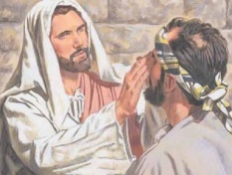
Fourth Sunday of Lent - March 22nd
Come to the Darkness....Discover the Light

Remarks & Relevance - Sr. Ann
Welcome & and for some Welcome Back! Anyone have any Well experiences or conversations with Jesus about living water they would like to share with us????
Come along with me now...to an encounter between Jesus and a blind man. Let’s try to grasp a deeper understanding of blindness and sight - sin and judgment - belief and commitment. Let’s SEE what Jesus and this blind man have to teach us as we listen, reflect and share with each other.

Read Gospel (scroll to end) - Reflect & Share (meaningful words/phrases & why)
In the previous chapter, Jesus is preaching in the temple about many things. The Scribes and Pharisees continue to question him. During that dialogue, Jesus states “I am the light of the world. Whoever follows me will not walk in darkness, but will have the light of life.”

Jesus leaves the temple and continues on his journey with his disciples. They pass a blind man, probably sitting by the roadside. In their effort to understand, they ask Jesus to clarify a common belief about blindness being associated with sin, or a punishment from God. Was it due to this man’s sin or his parents that he is blind? Of course, Jesus dispels this thinking and says it is so that the works of God might be made visible through him. Again, he says “I am the light of the world”.

I have thought a lot about this passage and blindness or other afflictions that people are burdened with. We say “why, why, why? Thankfully, we don’t hold on to the belief that it is due to either that person’s or parent’s sinfulness. But we do know that it must have been permitted by God for some reason. Many times we are able to discover the “why” and at other times we deal with anger or frustration. I know that I take sight for granted, and when problems occur....GLASSES....to the rescue!

What is Jesus planning to teach his disciples, this man and the questioning Pharisees in this Gospel? Jesus sees, Jesus acts.....and the process gets messy. Spit, dirt, smearing mud on his eyes. Yuck! Go, wash in the Pool of Siloam. I don’t know how far away it was, or how he got there, but he did as Jesus told him. He washes the mud from his eyes and now he sees.

As I thought about this passage, I couldn’t help but think about the procedures (often messy and inconvenient) many people with afflictions go through. Chemo, radiation, physical therapy, canes, crutches, wheelchairs. Some are temporary and bring relief; others are permanent. Some offer hope; others do not.
These conditions are not always due to sinfulness, but so that the works of God might be revealed in some way. Sometimes the “light” of understanding becomes clear and at other times, the darkness remains. Let’s keep delving into this passage about the blind man.
The blind man returns from the pool, looking around and SEEING.

Now the curiosity and questioning begins. What’s going on here? His neighbors and those who had seen him in his blindness start asking. Are you the blind beggar? What happened? He tells them that the man named Jesus made clay and anointed his eyes and to go to the Pool and wash them off.

So...off they go to the Pharisees and of course they question this cure because it was done on the Sabbath. The man is questioned again about the one who cured him. He declares “He is a prophet”. Then his parents are summoned. They state that this is their son - yes, he was born blind - we don’t know how he can see now - ask him - he’s old enough to tell you. The parents are afraid that if they acknowledge that Jesus healed him, they will be expelled from the synagogue.

Back and forth they go until the man finally says: “I told you - you won’t listen”.
Doubt and belief - discipleship and tradition. The man tries to express his belief in Jesus and they reject him. What does this man do with this gift of sight and belief in the one who did it for him? A blessing and another affliction!

Once again Jesus finds him and the man’s faith deepens. Do you believe in the Son of Man? Yes, where is He? Right here, speaking to you! I believe!
A faith encounter and final explanation follows. Jesus tells him that he did not come into the world to be judged, but rather for those who do not see to see (like you) who have received “insight and belief”. He also came so that those with sight (who think they know) might become blind and fail to accept the truth and believe in him. (like the Pharisees). He gave them something to think about and all of us as well.

So, we could listen to this passage on Sunday and respond with the words “Thanks be to God” when the end is reached and we are tired of standing and finally hear “The Gospel of the Lord”. We will listen for the priest to offer us further insight on what it means. Or, we could continue to reflect on thoughts presented here tonight and what you share with each other.
Our theme for this gospel passage is “Come to the Darkness.... Discover the Light”. Perhaps it’s better stated as “Come to the reality of the “darkness” that sin can cause us to be blinded to God’s love and merciful forgiveness that can bring us OUT of the Darkness (of sin) .... in order to Discover the Light” ... of Christ given to us during the Easter season. Aside from physical blindness, there is also a spiritual blindness that we may or may not be burdened with. Lent is a good time to think about this. The blind man faced many questions about his blindness. Sinfulness being the cause (his or his parents) - improper practice on the Sabbath (on the part of Jesus) - or ridicule from the Pharisees (do you want to become his disciple....we are disciples of Moses).

With spiritual blindness we can keep plugging along. We won’t be noticed by Jesus as we sit begging by the roadside. However..... we will be noticed wherever we are, by whatever we are doing, because he loves us and wants to encounter us in some way. He wants to reach out and touch us, even though the process may be messy. He wants us to believe in him more deeply and sincerely. He wants to be the Light that shines in the darkness of whatever it is in our life that pulls us away from Him.

The Pharisees threw the man out of the temple because they were convinced he was born blind because of his sinfulness and that now he was trying to teach them something since they were the educated ones. They didn’t want to hear it. They had sight, but they were blind to the ways of Jesus.

There is a difference between sight and “insight”. We often get insight into many things - like seeing someone smile, but they are crying inside. Or a response to how they are doing, when you know better than “I’m fine”. There are many signs around us that warrant insight and I’m sure you are good at recognizing this. Especially parents in regard to children and their moods and reactions. Adults are no exception.

Sometimes, the process for spiritual insight might be messy, difficult and inconvenient. It may be that tug on our heart that calls us to deeper insight into how we should do something to respond to our spiritual needs. It is then when we need to feel the presence of Jesus in our midst and respond to what we know we must do or say. That’s when we need to follow the example of the blind man.

Perhaps we haven’t been to Confession for a long time and know we need to go.
Perhaps we rarely make time for quiet and personal prayer and know it helps.
Perhaps we get to Mass late, and never have time to “connect” with God about our week and know we need to do that.
Perhaps we receive Communion as routine and need to remember the Real Presence that Jesus is sharing with us, to sustain us during the week.
Perhaps we have no patience or tolerance for those who get on our nerves and know we need to do better, with the help of Jesus.
Perhaps we have opinions about people and situations that may need deeper insight and need to be more open to their needs or perspectives.
I’m sure you can add to this list from your own perspective and situations.

This Gospel has much to offer us and teach us. Don’t just listen and soon forget.
Take it into your hearts and your homes. Discover what it can teach your children, with you help. Although our days may be getting brighter with the coming of spring - don’t be afraid - or reluctant to: Come to the Darkness (or out of).....and..... Discover the Light

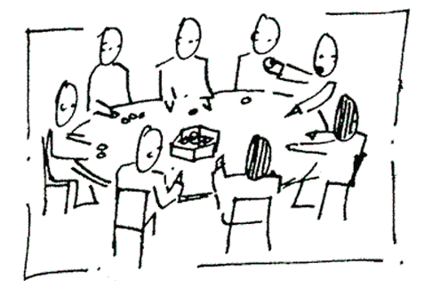
Fourth Sunday of Lent
Come to the Darkness....Discover the Light

Faith Sharing Questions at Tables
Based on Gospel for Fourth Sunday of Lent - March 18th (John 9: 1-41)

1. Why did Jesus put the blind man through a slow, messy process before healing him?
Have you, or someone you know ever experienced something similar; either physically or spiritually? What was the outcome?

2. Did you ever encounter someone who had a life-changing spiritual experience? How did you and others react?

3. The Pharisees had one view of how to keep the Sabbath. Jesus had another. How would you describe the ways you keep the Sabbath?

4. In what ways do you identify with the blind man and his process of seeing and believing?

5. What did Jesus mean by his final quote to the Pharisees: “If you were blind, you would have no sin; but now you are saying, “we see” so your sin remains? (consider this from the spiritual aspect of sin and forgiveness)

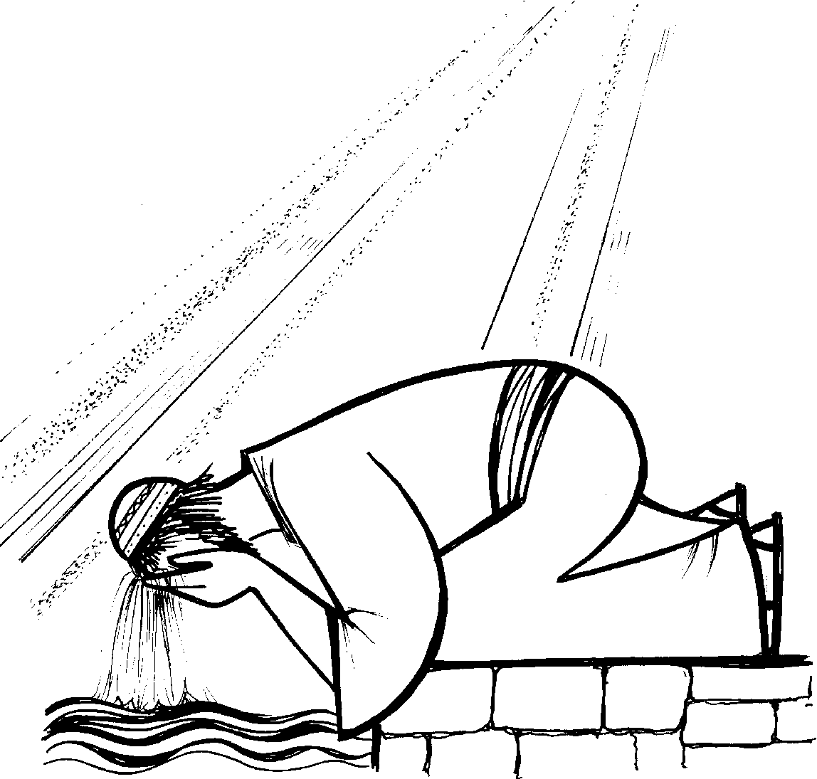
Fourth Week of Lent
Come to the Darkness ....Talk with Jesus
March 22nd

FAMILY TIME - SOME SUGGESTIONS
Note: Ages of children need to be considered.

Prepare a prayer space in your home similar to the one displayed here.
Bible (open to John 9: 1-41) - cross or crucifix - container of mud - sunglasses, picture of a pool.
Purpose: to remind us to look more closely at our blind spots (whatever they are ) and talk about ways, with the help of Jesus, we can discover deeper insight.
Depending on ages and schedules, at least once during the week gather as a family and announce....

We are often in the darkness, especially in regard to what we fail to see in regard to our sinfulness.
We hope Jesus notices us, helps us through the “messiness” of admitting whatever it is and sends us to the Pool (of the confessional) so we can SEE more clearly!

Mom or dad can take the lead and explain (age appropriate) about the different ways we tend to be blind - in our judgments, in our determination, in our opinions, etc. Perhaps share with each other about this. We may not be physically blind like this man, but sometimes blind to what is right and wrong. Knowing about God and our faith can sometimes be very different from the ways we practice this in our life.

Provide some examples and experiences. Read this Gospel passage (John 9: 1-41). Explain if necessary. Take a couple of minutes to be quiet and think about these questions:

- Put on a blindfold, or pretend to be blind and imagine what that would be like. Think about this blind man and how he must have reacted when Jesus made mud and put it on his eyes? How would you have reacted? What would you have said or done when you were told to go somewhere and wash it off.

- When do you give praise and thanks to God for the “small” miracles you have witnessed? What are they?

- What messy things have you seen in order for some good things to happen?

- Jesus was labeled as a sinner because he worked and healed the blind man on the Sabbath. In what ways do you tend to label people when they do something good for someone?

- Decide as a family when you will receive the Sacrament of Reconciliation during Lent.
Celebrate the washing away of whatever is messy in your life so that you can recognize how much Jesus love you and wants you to follow him as disciples.

Conclude with this prayer: Jesus said: “I am the light of the world”. (repeat) Jesus, help me see you in new ways in my life. (repeat)

Fourth Sunday of Lent - (March 22nd) - Gospel: John 9: 1-41

- Jesus Heals the Blind Man

As Jesus passed by he saw a man blind from birth. His disciples asked him,
“Rabbi, who sinned, this man or his parents, that he was born blind?”
Jesus answered, “Neither he nor his parents sinned; it is so that the works of God might be made visible through him. We have to do the works of the one who sent me while it is day.
Night is coming when no one can work. While I am in the world, I am the light of the world.”
When he had said this, he spat on the ground and made clay with the saliva, and smeared the clay on his eyes, and said to him, “Go wash in the Pool of Siloam” —which means Sent—.
So he went and washed, and came back able to see.
His neighbors and those who had seen him earlier as a beggar aid, “Isn’t this the one who used to sit and beg?” Some said, “It is,” but others said, “No, he just looks like him.” He said, “I am.”
So they said to him, “How were your eyes opened?” He replied, “The man called Jesus made clay and anointed my eyes and told me, ‘Go to Siloam and wash.’ So I went there and washed and was able to see.” And they said to him, “Where is he?” He said, “I don’t know.”
They brought the one who was once blind to the Pharisees.
Now Jesus had made clay and opened his eyes on a sabbath. So then the Pharisees also asked him how he was able to see. He said to them, “He put clay on my eyes, and I washed, and now I can see.”
So some of the Pharisees said, “This man is not from God, because he does not keep the sabbath.” But others said, “How can a sinful man do such signs?”
And there was a division among them. So they said to the blind man again, “What do you have to say about him, since he opened your eyes?” He said, “He is a prophet.”
Now the Jews did not believe that he had been blind and gained his sight until they summoned the parents of the one who had gained his sight. They asked them, “Is this your son, who you say was born blind? How does he now see?”
His parents answered and said, “We know that this is our son and that he was born blind. We do not know how he sees now, nor do we know who opened his eyes. Ask him, he is of age; he can speak for himself.”
His parents said this because they were afraid of the Jews, for the Jews had already agreed
that if anyone acknowledged him as the Christ, he would be expelled from the synagogue.
For this reason his parents said, “He is of age; question him.”
So a second time they called the man who had been blind and said to him, “Give God the praise!
We know that this man is a sinner.” He replied, “If he is a sinner, I do not know.
One thing I do know is that I was blind and now I see.”
So they said to him, “What did he do to you? How did he open your eyes?” He answered them,
“I told you already and you did not listen. Why do you want to hear it again?
Do you want to become his disciples, too?” They ridiculed him and said, “You are that man’s disciple; we are disciples of Moses! We know that God spoke to Moses, but we do not know where this one is from.” The man answered and said to them, “This is what is so amazing,
that you do not know where he is from, yet he opened my eyes.
We know that God does not listen to sinners, but if one is devout and does his will, he listens to him. It is unheard of that anyone ever opened the eyes of a person born blind.
If this man were not from God, he would not be able to do anything.” They answered and said to him, “You were born totally in sin, and are you trying to teach us?” Then they threw him out.
When Jesus heard that they had thrown him out, he found him and said, “Do you believe in the Son of Man?” He answered and said, “Who is he, sir, that I may believe in him?”
Jesus said to him, “You have seen him, the one speaking with you is he.”
He said, “I do believe, Lord,” and he worshiped him.
Then Jesus said, “I came into this world for judgment, so that those who do not see might see,
and those who do see might become blind.”
Some of the Pharisees who were with him heard this and said to him, “Surely we are not also blind, are we?” Jesus said to them, “If you were blind, you would have no sin; but now you are saying, ‘We see,’ so your sin remains.

